PackageStatusReporter.py

Alex Dowling-Deslauriers  
[alex@stalco.ca](mailto:alex@stalco.ca)  
Last Revised: 2021-04-28

Table of Contents

|  |  |
| --- | --- |
| 0. | Summary |
| 1. | Updating Database |
| 2. | Scanning Tickets |
| 3. | Uploading to Google Sheets |

Summary

PackageStatusTracker can be found in:  
W:\Logistics\Tools\PackageStatusReporter

Updating Database

1. Download 3PLC Data

Open 3PLC:  
[https://secure-wms.com/webui/login?callbackUri=https://secure-wms.com/smartui/&tplguid={8f403968-22c2-46f2-8942-6aaa7b846398}](https://secure-wms.com/webui/login?callbackUri=https://secure-wms.com/smartui/&tplguid=%7b8f403968-22c2-46f2-8942-6aaa7b846398%7d)

2. Specify the Data you wish to upload to the Database

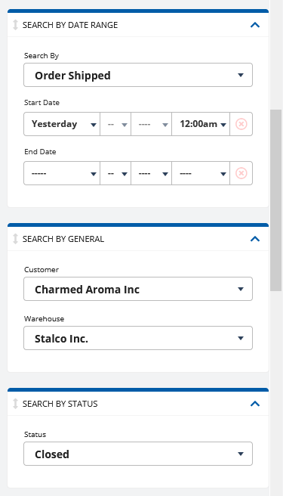

*Example: All shipped (closed in Techship, ready to ship) orders prepared since yesterday for Charmed Aroma*

Load all the orders if the count is over 4000



3. Click *Options* > *Export to Excel*

4. In PackageStatusReporter, click the *Browse* button in the *Upload File to Database* section

5. Select the file you just exported and then click *Load New Entries*  
6. Please wait patiently while database updates. You will receive 2 messageboxes: one confirming that the file was successfully read and that duplicates were removed, and another confirming that the database has been updated

*Please note that for technical reasons this can be very slow (1+ minute to update). We’re working on improving this*

Scanning Tickets

Scanning a ticket sets that order’s *StalcoStatus* to *Shipped*. It also adds a timestamp as to when the package was scanned out. We can assume that if a package is scanned out, it was also shipped out on that day.

There are 2 methods to scan pick tickets.

Method 1: Uploading Scan Sheets

*Used if you have already prepared an .xlsx file you send to Logistics.  
.xlsx file must have a cell in the top row called “Batch”, with all the scans in the column below that*

1. In PackageStatusReporter, click the *Browse* button in the *Upload Scans File* section  
2. Select the scans file prepared earlier and then click *Load File*  
3. Please wait patiently while database updates. You will receive 2 messageboxes: one confirming that the scans matched the database (or noting if not all scans matched, in which case you need to update the database), and another confirming that the database has been updated

Method 2. Manually Entering Scans

You can also scan pick tickets directly into the textbox.

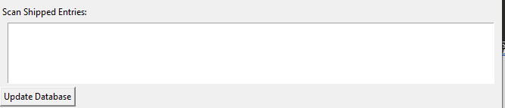

1. Click in the Textbox  
2. Use a gun scanner to scan every ticket  
3. Click *Update Database  
4.* Please wait patiently while database updates. You will receive 2 messageboxes: one confirming that the scans matched the database (or noting if not all scans matched, in which case you need to update the database), and another confirming that the database has been updated

Uploading to Google Sheets